# **CIS 451 Homework 2**

Only problems 5 - 7 are due for credit.

1. Show how to build a NAND gate using only NOR gates. Hint: Use [De Morgan's Theorems](http://www.allaboutcircuits.com/vol_4/chpt_7/8.html). You can also use [google](http://www.google.com/) to find more extensive discussions [on the web](http://www.allaboutcircuits.com/vol_4/chpt_7/8.html).

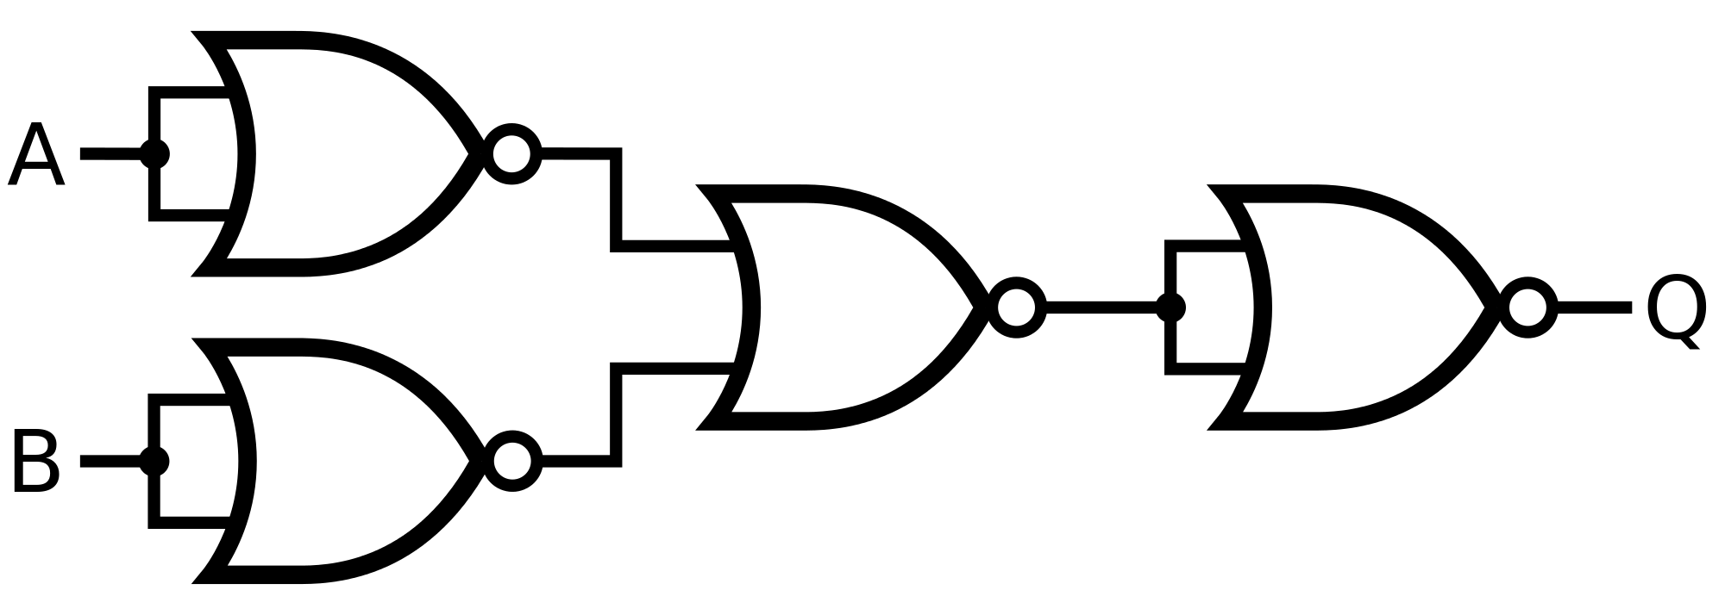

1. Show that {NOR} is logically complete. Your "proof" must include sentences. Diagrams alone are not sufficient.

NOR can be shown to be functionally complete by proving that we can create both the AND and the NOT gates with only NOR gates. We know that the set of {AND, NOT} gates are functionally complete, so by creating both the AND and the NOT gate with the NOR gate will prove that NOR is functionally complete.

By setting the inputs of one NOR gate to both be A, and the inputs of a second NOR gate to both be B, then having the two outputs of those gates become the inputs for a third NOR gate, we create the final output that is equal to that of an AND gate.

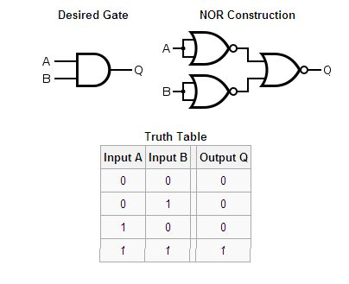

By having both inputs of a NOR gate come from the same input, the output of the gate is equivalent to that of a NOT gate.

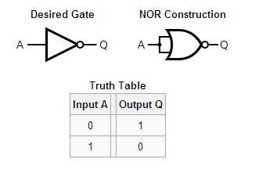

Therefor, because we know that the set of {AND, NOT} gates is logically complete, and we proved that both AND and NOT gates can be constructed from NOR gates, we know that the NOR gate is a logically complete gate.

1. Using the relay shown below as a model, show how you could combine one or more relays to build a NAND gate.

